

SIMATS ENGINEERING

Saveetha Institute of Medical and Technical Sciences
Chennai- 602105

Student Name: R.Thrishank Reg. No.: 192572182
Course Code: CSA1013 Slot: B
Course Name: Software Engineering
Course Faculty: Dr.R.Latha
Project Title: Campus Flow-An Event-Driven Campus Management System
with Role-Based Student, Teacher & Admin Portals
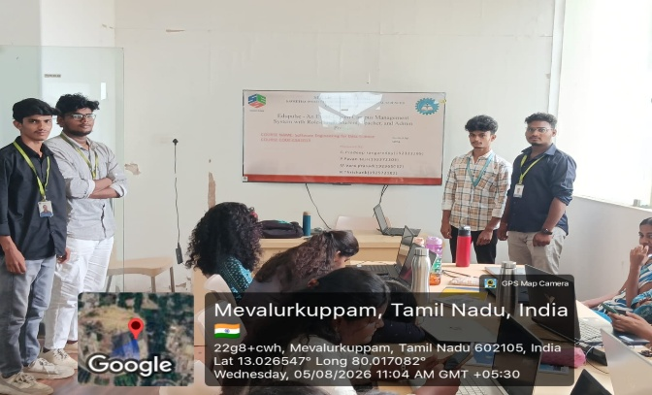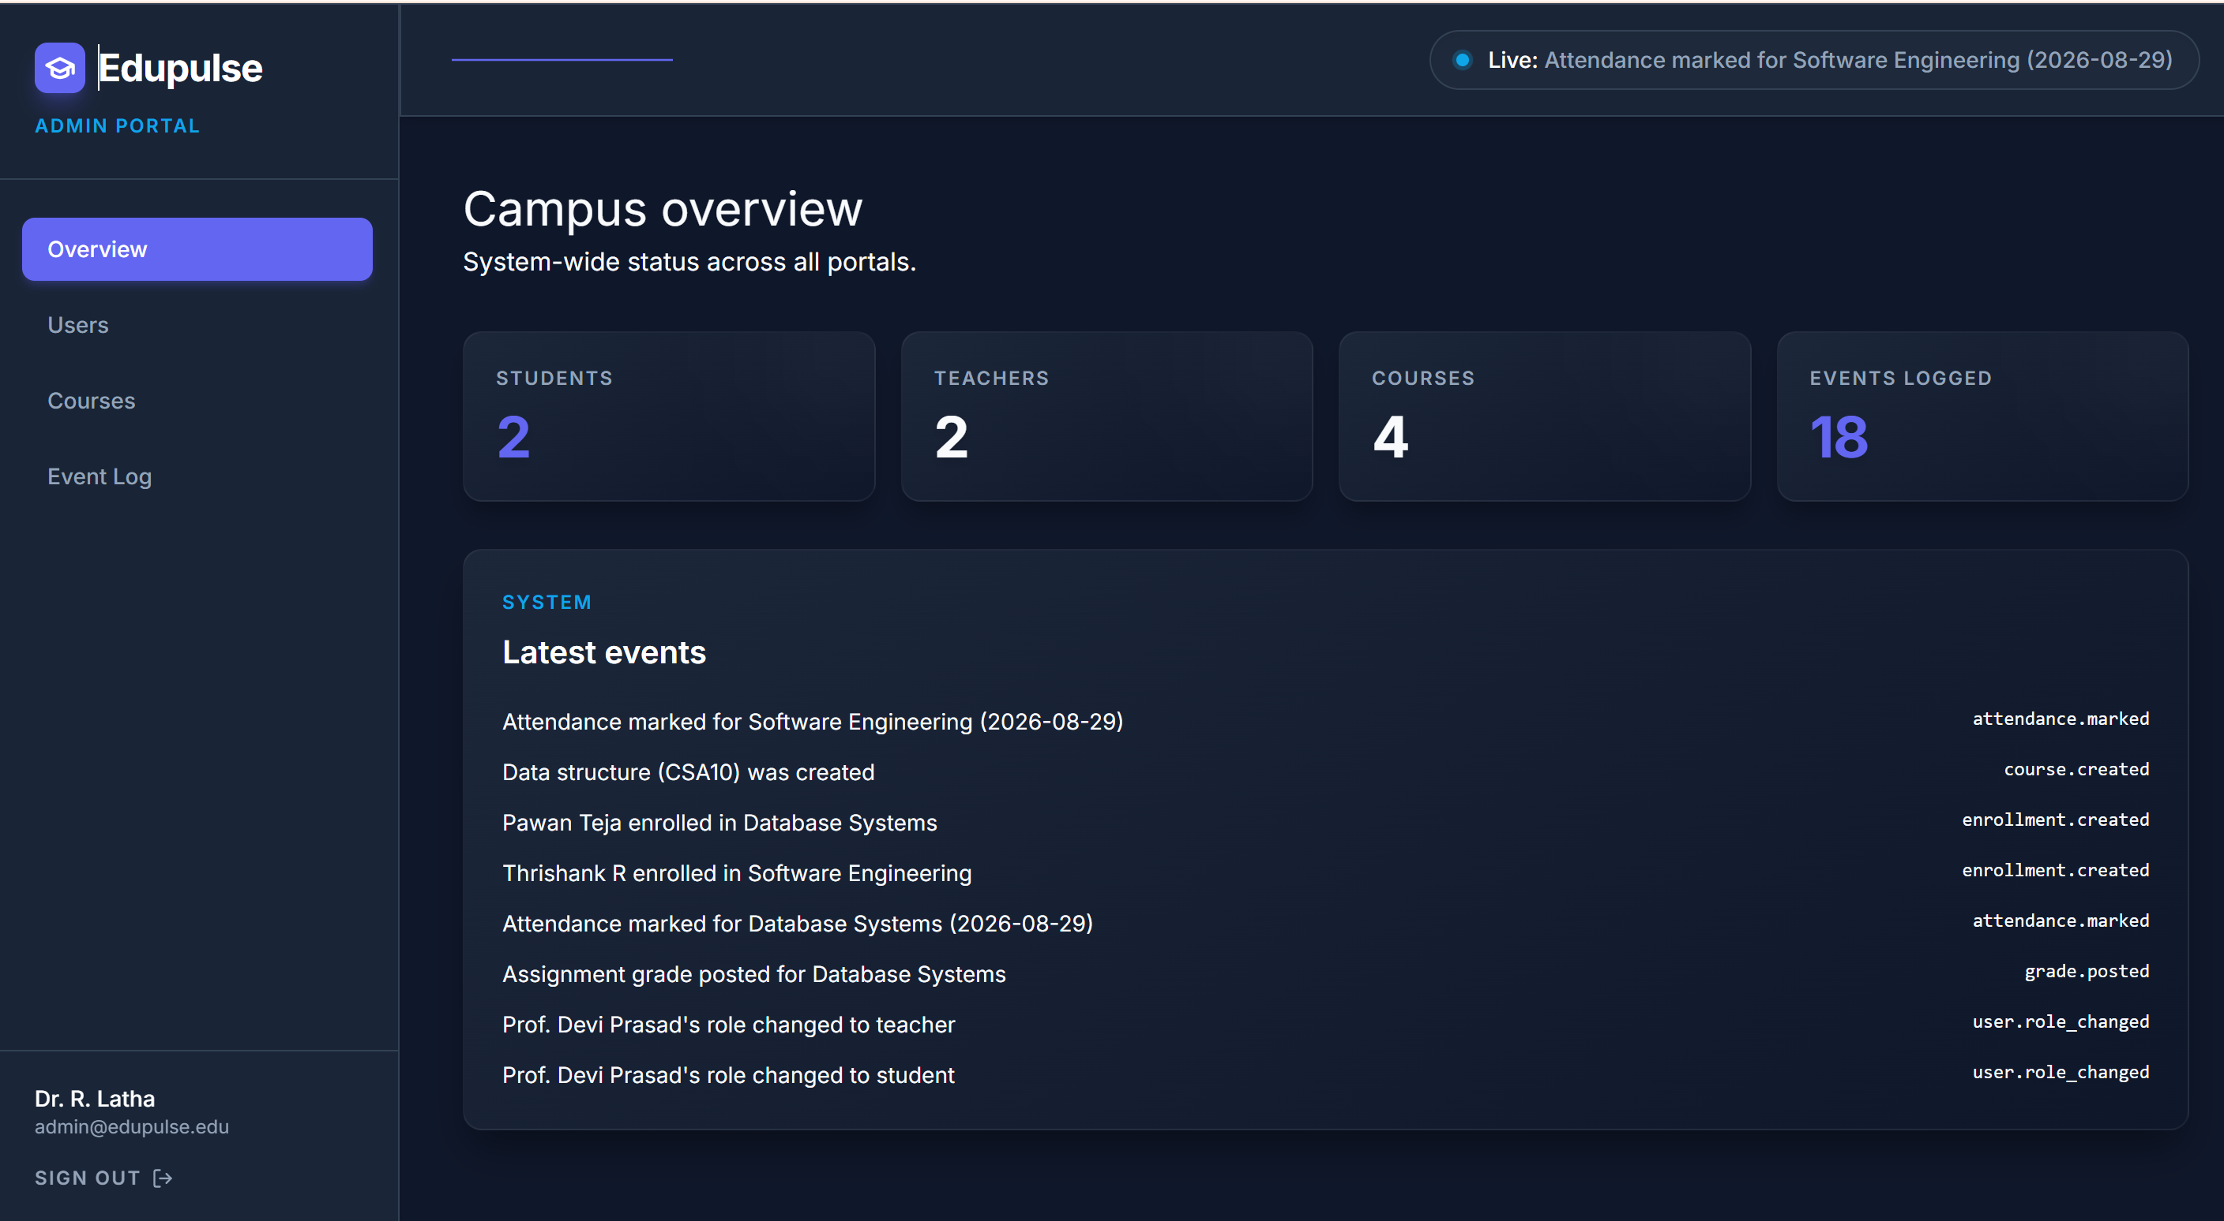

Project Description:
The system is responsible for handling real-time events, notifications, and system monitoring in the EduPulse Event-Driven Campus Management System. It uses an event listener and trigger service to detect system-wide events such as attendance updates, announcements, and academic activities. These events are placed into an event queue for reliable and organized processing. The notification service processes the events and sends real-time notifications to students, faculty, and administrators through integrated Email/SMS services. The logging and monitoring service continuously tracks system health, event processing, and service activities, improving communication, reliability, monitoring, and traceability across the campus management platform.

Student Signature
R.Thrishank Guide Signature

